
Plant Leaf Classification using CNN and Transfer learning approach

Muhammad Ahsan
MSc Data Analytics, CCT College Dublin
30 - 34 Westmoreland St., Dublin Tel: +353 1 6333444
Fax: +353 1 6333446
Email: info@cct.ie

Abstract
This research is all about how important it is to classify plants, especially using their leaves. The study emphasizes the role of leaves in automated plant classification, highlighting their significance in agriculture and pharmaceuticals. The researchers use advanced deep learning models like CNN and pre-trained ResNet50, Mobinet, and VGG16 to make this classification task super effective. By focusing on the features of plant leaves, this research aims to boost accuracy and efficiency in identifying various plant species. An additional challenge tackled in this paper is the limited dataset size. Acknowledging this constraint, I implemented data augmentation techniques. By artificially expanding the dataset, I aimed to enhance the robustness and generalization capabilities of the models. In this research, I explored the importance of plant classification, especially using leaves, and went a step further. I compared various research papers and deep learning models, specifically CNN and pre-trained ResNet50, Mobinet, and VGG16. By making this comparison, I aimed to determine which model performs the best for automated plant leaf classification. The goal was to identify the most effective approach and contribute valuable insights to the field.
Index Terms- Classification, Convolutional Neural Network, Deep Learning, Transfer learning, Data Augmentation
Introduction:
In the complex world of plant species identification, Identifying and categorizing plants are among the most critical challenges facing agricultural research and products. Strong knowledge of plants is necessary for recognizing new and unique species of plants, which is essential for enhancing pharmaceuticals, environmental balance, agricultural usage, and robustness. [1]Despite the various contributions made in machine learning, plant identification looks like a tricky and unresolved problem. This is because, in reality, all plants look similar in color and shape. Furthermore, this complex task has incorporated plant leaf morphology differences in size, thickness, shape, contour, and other factors.
The features such as shape, surface, and contour are used for recognizing leaves of distinct species of plants. Handcrafted and deep learning features are two primary feature extraction approaches to analyze leaf pictures. The creation of handcrafted features is extracted by computer vision specialists who encode morphological features set by botanists. On the other hand, the deep learning features can be learned automatically using deep learning algorithms. Deep learning is a novel and advanced data analysis and image processing technology that gives promising outcomes. Deep learning has been effective in a variety of disciplines, and recently started working in the area of agronomy and food. As a result, deep learning-based leaf identification has gained popularity.

Deep Learning Approach
To train a deep learning algorithm, one needs a large volume of data, greater computational power, cost, time, and sometimes, training days. However, in practical applications, gathering and classifying a massive amount of data in a specific area is a consuming and expensive challenge and might not be possible. As a result, in various situations, acquiring a considerable amount of data in particular fields may not be acceptable. [2]. Here, a feature map is formed by a series of consecutive convolution operations between the input image and convolutional filters, and discriminative patterns are extracted from individual plant leaves. Several image recognition methods and applications based on deep learning are easily accessible and are still attracting much attention. These methods could be applied to botany and agriculture to tackle problems computationally.

Models
In the pursuit of enhancing plant leaf classification through deep learning methodologies, we trained multiple models, each bringing unique architectural characteristics to the forefront. This research-trained Convolutional Neural Network (CNN) model demonstrated commendable performance, achieving an accuracy of 96.19% with a corresponding loss of 0.13. We further delved into integrating pre-trained models VGG16, MobileNet, and ResNet50 through transfer learning. The VGG16 model exhibited remarkable accuracy, surpassing expectations at 99.73%, with a minimal loss of 0.01. Similarly, the MobileNet model yielded a noteworthy accuracy of 98.64%, with a loss of 0.08. ResNet50, known for its depth and residual connections, showcased an impressive accuracy of 99.45% with a loss of 0.23. This comparative analysis provides insights into the accuracy achieved by each model and sheds light on their efficiency in our plant leaf classification task. Such findings are crucial for informed decision-making in selecting an optimal model for applications in agriculture and environmental sciences.

Dataset
Starting our exploration into plant leaf classification, this paper relies on a purposefully chosen dataset from Kaggle. This resource lays the foundation for unraveling the intricacies of image classification. Augmented to enhance its diversity, this dataset becomes a crucial canvas for exploring innovative deep-learning models in plant sciences on nine distinct classes: Cassava, apple, cherry, grape, orange, pepper, bell, squash, strawberry, and tomato. Despite its relatively modest size, consisting of 1837 images for training and 157 for validation, its diversity and thoughtful representation of various plant species make it a valuable asset for research and development in computer vision. Recognizing the importance of augmenting the dataset to enhance its size and variability, data augmentation techniques have been applied. This augmentation strategy contributes to the robustness of the dataset, enabling models to generalize better and perform effectively on a broader range of plant leaf images. Researchers and practitioners engaging with this dataset can leverage its unique characteristics to advance the state-of-the-art in plant leaf classification, fostering innovations in agriculture, botany, and environmental sciences.
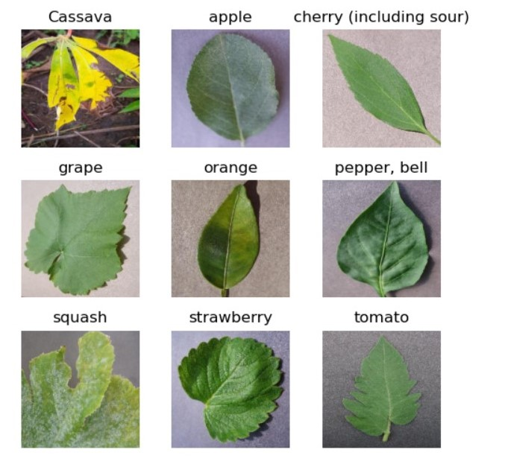

Figure 1

Related work

Classification of Plant Leaves Using New Compact Convolutional Neural Network Models
This paper proposes using compact convolutional neural network (CNN) models to detect and classify plant leaves, achieving high accuracy in ranking nine species of plants from the PlantVillage dataset and 32 classes from the Flavia dataset.
The proposed models significantly improve classification accuracy through data augmentation techniques and require less training than the AlexNet model.
The models are also effective in classifying diseases in tomato plant leaves.
The dataset used for training consists of 38,400 images and an augmented dataset of 336,000 images.
- Leaf Classification for Plant Recognition with Deep Transfer Learning
This paper presents an efficient method for plant recognition using deep transfer learning, specifically transfer learning with a pre-trained deep neural network model and a logistic regression classifier for leaf classification.
The proposed method achieves high accuracy in leaf classification on two well-known botanical datasets, Flavia and Leaf Snap, with accuracy rates of 99.6% and 90.54%, respectively.
The method outperforms traditional feature-based and deep learning-based methods regarding memory and precision.
The paper highlights the potential and promising results of deep learning in image processing and data analysis, specifically in plant recognition.
- Plant Leaf Classification Using Fine-Tuned Transfer Learning
The paper focuses on plant leaf classification using fine-tuned transfer learning. Deep learning algorithms, such as CNN and transfer learning models, identify plant species based on leaf images. Regularization techniques like batch normalization and dropout are employed to address overfitting issues. Transfer learning and parameter fine-tuning are effective in achieving high accuracy. The proposed approaches are tested on the Leafsnap dataset, reaching a peak training accuracy of 98.64% and a peak testing accuracy of 95.78%

Proposed Method

There are lots of other methods that are used for classification in Deep learning. Training the model to adequately and correctly classify objects is a huge task that artificial intelligence practitioners have been working hard on for many years now, and plant classification is no different in this feat. Variations on leaf characteristics are preferably employed in automated plant identification systems using computer vision methods because leaves are easily observable, accessible, and describable compared to other plant organs.

Preprocessing
This research paper focuses on various plant classes, including Cassava, apple, sour cherry, grape, orange, bell pepper, squash, strawberry, and tomato. This research paper uses a dataset from the Kaggle platform. Our training dataset, sourced from the specified directory, encompasses a variety of leaf images for each class, forming the foundation for our plant leaf classification task.
We adopt a batch size of 32 to ensure robust model training and standardize image dimensions to 224x224 pixels. We split the dataset into training and validation sets, with a validation split of 80% and 20%. The training set, represented by “train_ds,” is augmented for improved generalization using random horizontal flips, rotations, and zooms. This augmentation is vital for enhancing the model's ability to discern patterns across various orientations and scales. The dataset is further pre-processed through caching, shuffling, and prefetching operations, optimizing its accessibility during model training. We introduce a normalization layer to rescale pixel values to the range of [0, 1], ensuring uniformity in the input data. The impact of these transformations is exemplified by examining a sample image batch, showcasing the pixel value normalization.

Feature Extraction
[3]This process is known as transfer learning, where the knowledge gained from one task is transferred to a different but related study. By removing the fully connected layers and connecting the output of the convolutional layers to a new classification layer, the models can be fine-tuned for the specific task of plant species recognition. This approach expedites training and enables the utilization of learned features from large datasets, enhancing the model's ability to discern intricate patterns in plant leaf images. For each model, including ResNet50, Mobinet, and VGG16, we systematically remove the original fully connected layers and replace them with a new classification layer tailored to our plant species recognition task. This tailored architecture allows us to fine-tune the models using our plant leaf dataset. By doing so, we effectively transfer the learned features from the broader domain of ImageNet to identifying plant species. This accelerates training and enriches our models with the ability to recognize subtle patterns unique to plant leaves, ultimately enhancing the accuracy and robustness of our plant species recognition system.
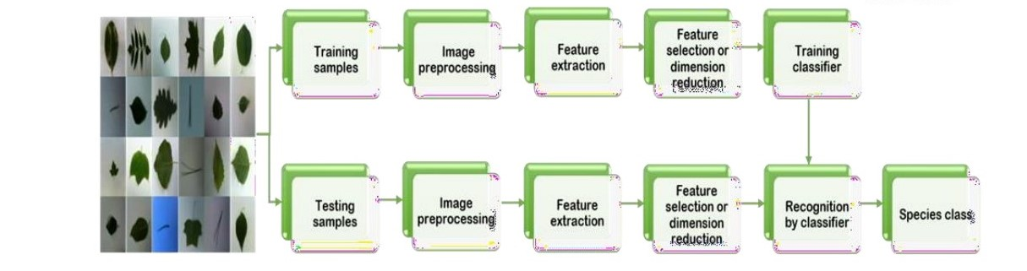
Figure 2

Convolutional Neural Network (CNN):

The Convolutional Neural Network (CNN) architecture performs convolution operations to learn features from the images. The sequential model commences with a data augmentation layer, augmenting the training dataset through random flips, rotations, and zooms to enhance the model's capacity for generalization. Subsequently, pixel values are rescaled to a normalized range. See Figure 3 for the flow diagram of CNN.
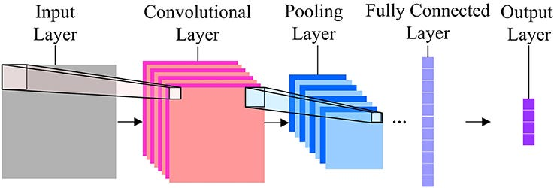
Figure 3
[1] The flattened output experiences further abstraction in two dense layers, comprising 128 neurons with ReLU activation and a final thick layer with nine neurons activated by softmax for multi-class classification. The model boasts a substantial parameter count of 6,447,401, attesting to its capacity to discern intricate patterns within the plant leaf dataset. This comprehensive architecture, depicted in the model summary, is poised for training, employing convolutional and data augmentation operations to classify plant leaves into their respective classes. In Figure 4, you can see all the parameters of the trained CNN model performed very accurately.
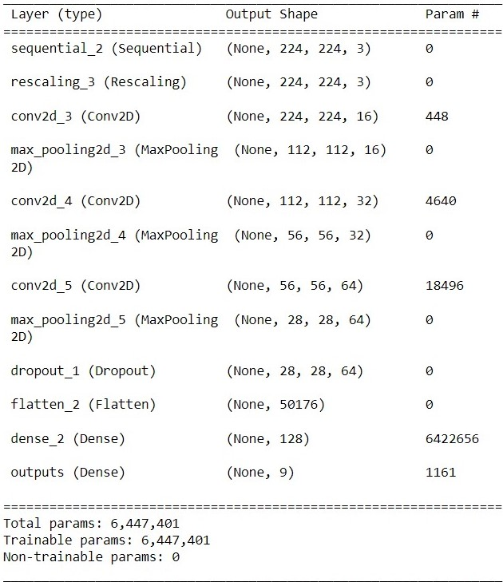
Figure 4

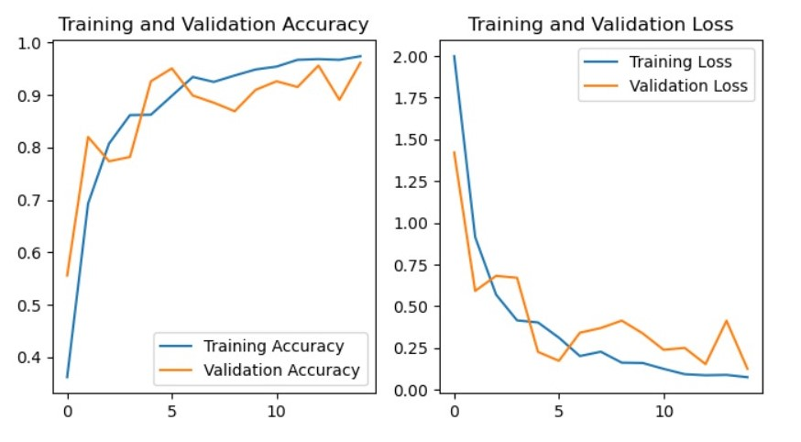
Figure 5
In the final training phase, the CNN model experienced 15 epochs, with each epoch encompassing a comprehensive iteration through the entire dataset. The training loss stabilized at 0.0756, indicating the model's effective reduction of errors and its capability to learn intricate patterns within the plant leaf images. Simultaneously, the training accuracy reached a commendable 97.41%, showcasing the model's proficiency in accurately classifying plant leaves into their respective species.

On the validation set, designed to assess the model's generalization performance on unseen data, the loss was measured at 0.1261. This underscores the model's capacity to generalize well to new instances, even those it hasn't encountered during training. A solid 96.19% validation accuracy further emphasizes the model's robust performance in predicting plant leaf classes beyond the training dataset.

Deep Learning pre-trained VGG16:
The VGG16 transfer learning model is a convolutional neural network architecture proven effective in image classification tasks. In your scenario, the model has undergone transfer learning, a process where a pre-trained VGG16 model, trained initially on a large dataset like ImageNet, is fine-tuned on your specific plant leaf classification task.

Figure 6
I first import the pre-trained VGG16 model using a deep learning framework such as Keras or TensorFlow. To preserve the knowledge gained during the original training on ImageNet, you likely froze the weights of the pre-trained layers. This ensures that these layers are not updated during the initial training on your plant leaf dataset. Then, I introduced a custom layer architecture after the pre-trained layers. [1]. The last dense layer likely has neurons equal to the number of classes in your dataset, activated by softmax for multi-class classification.
The model was trained on a plant leaf dataset for five epochs. The entire dataset was passed through the network during each epoch, and the model's weights were updated based on the calculated loss. This process iterated for five cycles, allowing the model to adapt to the characteristics of your specific plant leaf images.
Using a pre-trained VGG16 model accelerates the training process, capitalizing on the features learned from a diverse set of images in ImageNet. Fine-tuning your specific dataset through a limited number of epochs ensures that the model tailors its knowledge to the nuances of plant leaf classification.

Deep Learning pre-trained ResNet50:
The ResNet50 pre-trained model is the backbone for plant species recognition in my plant leaf dataset. Initially designed for sophisticated image recognition tasks, ResNet50's deep architecture, featuring skip connections, addresses the challenges of vanishing gradients during training.
The ResNet50 model aligns with the nuances of plant leaf classification. The 'Flatten' layer is introduced to convert complex feature maps from ResNet50 into a one-dimensional array. Subsequently, a dense layer with 200 neurons and ReLU activation is added for intermediate feature abstraction.
The concluding dense layer acts as the classifier, aligning with the number of classes in my plant leaf dataset. It utilizes softmax activation to assign probabilities to each class for effective multi-class classification.
This personalized architecture enables fine-tuning of ResNet50 on my plant leaf dataset, allowing it to adapt to specific visual characteristics and patterns in leaf images. Throughout the training, the model refines its parameters based on calculated loss, optimizing its proficiency in accurately classifying plant leaves into their respective species.
Training Validation
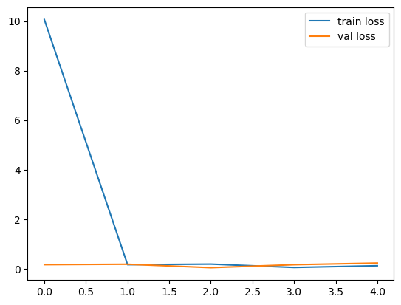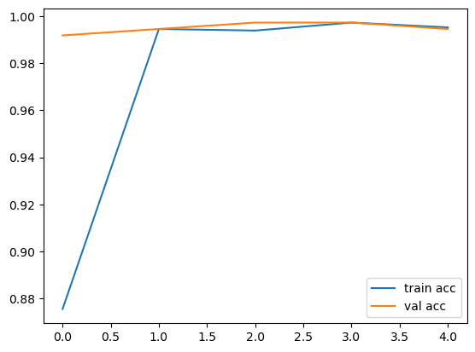
Figure 7

The model underwent five epochs in the training process, each representing a complete pass through the entire dataset. During this training phase, the model achieved notable performance metrics. The training loss steadily decreased over the epochs, reaching a value of 0.1201. Simultaneously, the training accuracy exhibited remarkable improvement, culminating at an impressive 99.52%.
On the validation set, which serves as an independent dataset to assess the model's generalization capability, the loss was evaluated to be 0.2285, and the accuracy attained an equally commendable value of 99.4%. These metrics signify the model's robust learning and generalization to new, unseen data. The achieved accuracy underscores the effectiveness of the ResNet50-based architecture in accurately classifying plant leaves in your dataset after just five training epochs.

Deep Learning pre-trained MobileNet:
The MobileNet pre-trained model has been harnessed as a foundational architecture for plant species recognition. Originating as an architecture well-suited for mobile and embedded applications, MobileNet boasts efficiency without compromising performance.
I extend the MobileNet model to adapt it to the intricacies of my plant leaf classification. The 'Flatten' layer is introduced to transform the multi-dimensional feature maps generated by MobileNet into a streamlined, one-dimensional array. Following this, a dense layer with 1000 neurons and a ReLU activation function is appended, acting as an intermediary layer for feature abstraction.
[2].
This customized architecture allows for fine-tuning MobileNet on my specific plant leaf dataset, enabling it to discern the unique visual characteristics and patterns inherent in my leaf images. The model iteratively adjusts its parameters based on calculated loss through training, refining its proficiency in accurately classifying plant leaves into their respective species.

Training Validation
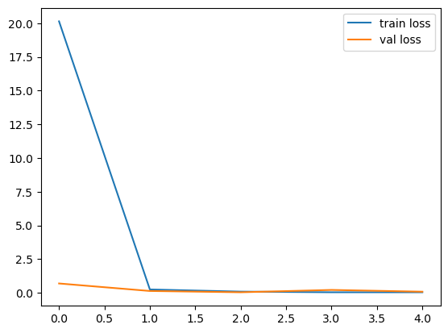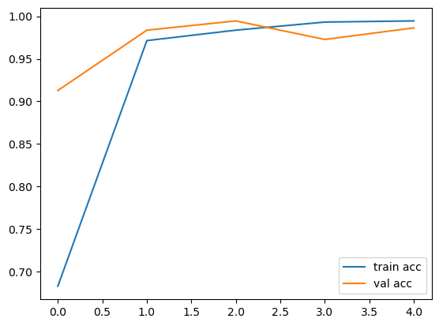
Figure 8

In five training epochs, each representing a comprehensive iteration through the entire dataset, the MobileNet-based model showcased remarkable performance. The training loss steadily decreased to an impressive 0.0396, signifying the model's aptitude in minimizing errors during the learning process. Simultaneously, the training accuracy reached a commendable 99.46%, attesting to the model's proficiency in accurately predicting plant leaf classes.

A separate dataset was used on the validation set to evaluate the model's generalization capabilities. The loss was measured at 0.0813. [4]The validation accuracy, an equally noteworthy 98.64%, underscores the robustness of the MobileNet architecture in accurately classifying plant leaves within my dataset. These metrics collectively affirm the success of the MobileNet model in achieving high accuracy while minimizing loss after just five training epochs.

Experimentation and comparison
For accurately identifying and recognizing the plant leaf with a deep learning model, we did many experiments using different parameters and methods. We used 1837 training images and 157 validation images to train our models. Let me explain to you all the experiments with the results.
[1]Employing data augmentation techniques, such as random flips, rotations, and zooms, added diversity to the dataset. The results after 15 epochs indicated a promising performance with a training accuracy of 97.41% and a validation accuracy of 96.19%.
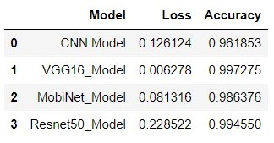
Figure 9
Subsequently, I delved into transfer learning using pre-trained models. The introduction of the VGG16 architecture led to an exceptional boost in performance, achieving a training accuracy of 99.73% and a validation accuracy of 99.46% after just five epochs. MobileNet, another pre-trained model, also demonstrated commendable results with a training accuracy of 98.64% and a validation accuracy of 99.46% over the same period. Furthermore, the exploration extended to ResNet50, which yielded comparable outcomes, showcasing a training accuracy of 99.52% and a validation accuracy of 99.46%. The convergence of these models to high accuracy levels, along with their low training losses, signifies the effectiveness of transfer learning in plant leaf classification. As I move forward, considerations for model selection, hyperparameter tuning, and model interpretability will guide the refinement of this classification system. Figure 9, shows the accuracy and loss of all models. I will show you the visualization of the results, too. But before that, we have to compare our results with the different research papers.
“Deep Learning-Based Recognition Technique for Plant Leaf Classification":
The paper presents the results of applying a Conditional Generative Adversarial Network (cGAN) for data augmentation, a Convolutional Neural Network (CNN) for feature extraction, and a Logistic Regression classifier for plant leaf classification. The method achieves high accuracy in classifying plant species using leaf images, with an average accuracy of 96.1% across multiple datasets and an even higher accuracy of 99.0% to 100% on individual datasets.
"Improving Plant Species Classification Using Deep Learning Techniques":
This paper uses a MobileNet model as a feature extractor and a logistic regression classifier for plant species classification. The experimental results show that the proposed method achieves high accuracy in classifying plant species, with an average accuracy of 94.69% on the Flavia dataset. The paper also discusses the limitations of deep learning methods and the need for data augmentation to overcome the problem of a small dataset.
"Deep Learning Approach for Plant Species Classification Using Leaf Images":
[4].
After training all the models, we test all models on the dataset that we have not used for training, which means the unseen data. On unseen data, CNN made one wrong prediction, but the other models, VGG16, ResNet50, and MobiNet, accurately predicted all five pictures. You can see the Figure 10.
Predict unseen data
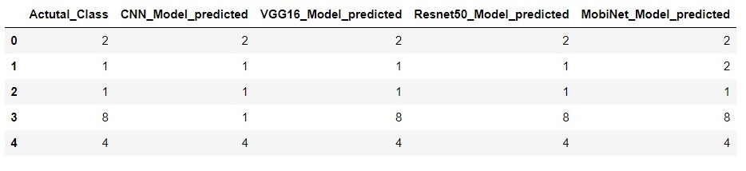
Figure 10

Conclusion

In conclusion, our in-depth exploration of plant leaf classification harnesses the power of diverse pre-trained models, including ResNet50, VGG16, and MobileNet, within Convolutional Neural Networks (CNNs). Our methodology prioritizes discriminative feature extraction from leaf images, showcasing the effectiveness of ResNet50 over hand-crafted features, as validated by logistic regression as a classifier. The augmentation of our dataset with conditional CNN contributes to model robustness, producing near-accurate synthetic leaf images.

Quantitative results further emphasize the notable performance of each model:

- The CNN model achieves a commendable accuracy of 96.19% with a loss of 0.1261.
- VGG16_Model exhibits exceptional accuracy at 99.73%, accompanied by an impressively low loss of 0.006278.
- MobiNet_Model achieves high accuracy of 98.64%, with a corresponding loss of 0.081316.
- ResNet50_Model demonstrates outstanding performance with an accuracy of 99.46% and a loss of 0.228522.

[1]. The observed success highlights the strengths of specific models and emphasizes the potential of diverse pre-trained architectures in addressing the complexities of plant leaf classification through deep learning. As we conclude, these results motivate continued exploration and optimization, potentially extending the applicability of our approach to diverse plant datasets for even broader generalization.

References
- Goodfellow, J. Pouget-Abadie, M. Mirza, B. Xu, D. Warde-Farley, S. Ozair, A. Courville, and Y. Bengio, ‘‘Generative adversarial networks,’’ Commun. ACM, vol. 63, no. 11, pp. 139–144, 2020, doi: 10.1145/3422622
- M. Keivani, J. Mazloum, E. Sedaghatfar, and M. Tavakoli, ‘‘Automated analysis of leaf shape, texture, and color features for plant classification,’’ Traitement Signal, vol. 37, no. 1, pp. 17–28, Feb. 2020, doi: 10.18280/ts.370103.
- P. Pawara, E. Okafor, L. Schomaker, and M. Wiering, ‘‘Data augmentation for the plant classification,’’ in Advanced Concepts for Intelligent Vision Systems (Lecture Notes in Computer Science), vol. 10617. Cham, Switzerland: Springer, 2017, pp. 615–626, doi: 10.1007/978-3-319-70353-4_52
- O. Ronneberger, P. Fischer, and T. Brox, ‘‘U-Net: Convolutional networks for biomedical image segmentation,’’ in Proc. Int. Conf. Med. Image Comput. Comput.-Assist. Intervent., 2015, pp. 234–241.
- J. Chaki and R. Parekh, ‘‘Plant leaf recognition using shape-based features and neural network classifiers,’’ Int. J. Adv. Comput. Sci. Appl., vol. 2, no. 10, pp. 1–12, 2011, doi: 10.14569/ijacsa.2011.021007.
- S. Mouine, I. Yahiaoui, and A. Verroust-Blondet, ‘‘Advanced shape context for plant species identification using leaf image retrieval,’’ in Proc. 2nd ACM Int. Conf. Multimedia Retr., Mar. 2012, pp. 1–8, doi: 10.1145/2324796.2324853.
- P. Isola, J.-Y. Zhu, T. Zhou, and A. A. Efros, ‘‘Image-to-image translation with conditional adversarial networks,’’ 2017, arXiv:1611.07004.
- F. Pedregosa, G. Varoquaux, and A. Gramfort, ‘‘Scikit-learn: Machine learning in Python,’’ J. Mach. Learn. Res., vol. 12, no. 85, pp. 2825–2830, 2011, Accessed: Oct. 30, 2021. [Online]. Available: http://jmlr.org/papers/ v12/pedregosa11a.htm
- N. Goyal, N. Kumar, and Kapil, ‘‘On solving leaf classification using linear regression,’’ Multimedia Tools Appl., vol. 80, no. 3, pp. 4533–4551, Sep. 2020, doi: 10.1007/s11042-020-09899-y
- D. Hall, C. McCool, F. Dayoub, N. Sunderhauf, and B. Upcroft, ‘‘Evaluation of features for leaf classification in challenging conditions,’’ in Proc. IEEE Winter Conf. Appl. Comput. Vis., Jan. 2015, pp. 797–804, doi: 10.1109/WACV.2015.111.
- P. Wilf, S. Zhang, S. Chikkerur, S. A. Little, S. L. Wing, and T. Serre, ‘‘Computer vision cracks the leaf code,’’ Proc. Nat. Acad. Sci. USA, vol. 113, no. 12, pp. 3305–3310, Mar. 2016, doi: 10.1073/pnas.1524473113.
- P. Wilf, S. Zhang, S. Chikkerur, S. A. Little, S. L. Wing, and T. Serre, ‘‘Computer vision cracks the leaf code,’’ Proc. Nat. Acad. Sci. USA, vol. 113, no. 12, pp. 3305–3310, Mar. 2016, doi: 10.1073/pnas.1524473113.
- J. Hu, Z. Chen, M. Yang, R. Zhang, and Y. Cui, “A Multiscale Fusion Convolutional Neural Network for Plant Leaf Recognition,” IEEE Signal Processing Letters, vol. 25, no. 6, pp. 853-857, 2018.
- J. Chaki, R. Parekh, and S. Bhattacharya, “Plant leaf recognition using texture and shape features with neural classifiers,” Pattern Recognition Letters, vol. 58, pp. 61-68, 2015
- R. Girshick, J. Donahue, T. Darrell, and J. Malik, “Rich feature hierarchies for accurate object detection and semantic segmentation,” in Proceedings of the IEEE Conference on Computer Vision and Pattern Recognition, 2014, pp. 580-587
- K. Chatfield, K. Simonyan, A. Vedaldi, and A. Zisserman, “Return of the devil in the details: Delving deep into convolutional nets,” arXiv preprint arXiv:1405.3531, 2014.
- H. Azizpour, A. Sharif Razavian, J. Sullivan, A. Maki, and S. Carlsson, “From generic to specific deep representations for visual recognition,” in Proceedings of the IEEE Conference on Computer Vision and Pattern Recognition Workshops, 2015, pp. 36-45.
- ] A. Sharif Razavian, H. Azizpour, J. Sullivan, and S. Carlsson, “CNN features off-the-shelf: an astounding baseline for recognition,” in Proceedings of the IEEE Conference on computer vision and pattern recognition workshops, 2014, pp. 806-813
- Joly A, Goëau H, Bonnet P, Bakić V, Barbe J, Selmi S, Yahiaoui I, Carré J, Mouysset E, Molino JF, Boujemaa N. Interactive plant identification based on social image data. Ecological Informatics. 2014 Sep 1;23:22-34
- Ghazi MM, Yanikoglu B, Aptoula E. Plant identification using deep neural networks via optimization of transfer learning parameters. Neurocomputing. 2017 Apr 26;235:228- 35.

